Labels,Selectors,ReplicationController and replicaset in Kubernetes

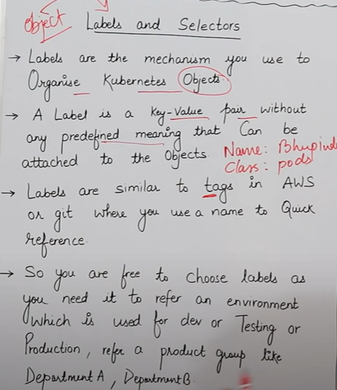

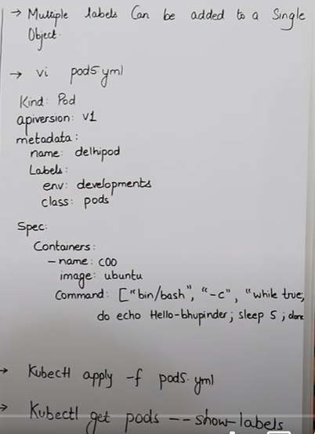

* Label eak key value pair hota hai , hum jaldi sein kisi cheej kar dhudh kar lane kein liye label lagate hai
* Hum eak object par eak sein jada label laga sakte hai .
* Label agar humko define karna hota hai toh usko hum apane yml file kein andar metadata kein andar define karte hai .
* **nano pod5.yml**

**kind: Pod**

**apiVersion: v1**

**metadata:**

**name: delhipod**

**labels:**

**satyamkey: tripathivalue**

**haryana: gurgaon**

**spec:**

**containers:**

**- name: c00**

**image: ubuntu**

**command: ["/bin/bash", "-c", "while true; do echo Hello-Gurgaon,how are you; sleep 5 ; done"]**

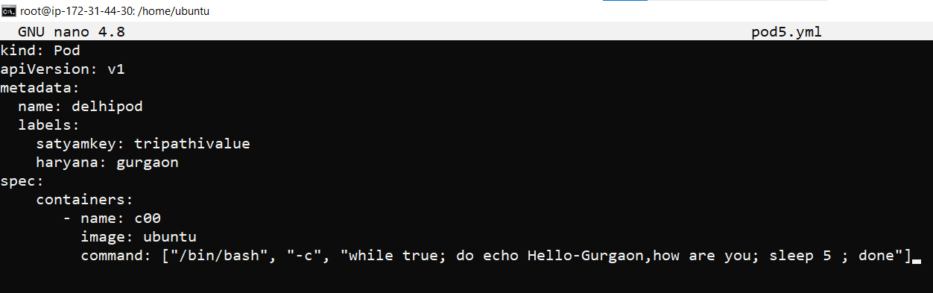

* **kubectl apply -f pod5.yml**

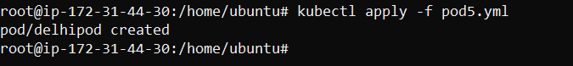

* **kubectl get pods**

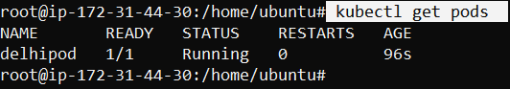

* **kubectl get pods -o wide**



* **kubectl get pods --show-labels**

Agar mujhe check karna ho ki kis pod par kaun sa label laga huva hai toh uske liye hum ye command use karenge.



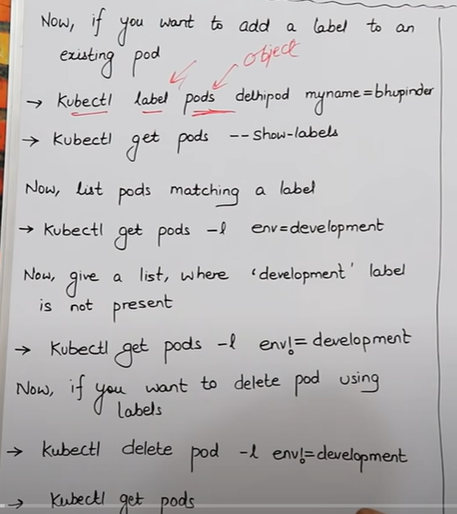

* **kubectl label pods delhipod myname=satyam**
* Agar mujhe koi running par koi label define karna ho toh uske liye hum ye command use karenge.
* Mene kubectl kein baad label likha hai phir uske baad pod aur phir pod ka name matlab kehane ka ki mene kubelet kein baad bata diya hai ki label lagao pod kein andar jaakar aur **delhipod** naam ka jo pod hai uspar **label laga do** ,aur phir mene define kiya **key value** **myname** meri **key**  hai aur **satyam** mera value hai.



* **kubectl get pods --show-labels**
* Ab mere pod kein andar mene jitane label define kiye honge sab dikh jayega iss command sein, aur mujhe 3 label dikhenge is pod mein , jisme sein 2 mene apane yml file kein andar define kar rakha hai aur eak label mene apane previously command mein bataya hai .myname = Satyam .



* **kubectl get pods -l haryana=gurgaon**
* agar mere pass bahut saree pod bane huve hai aur mujhe label daal kar pata karna hai ki vo label kaun sein pod mein pada hai toh uske liye hum ye command use Karenge,
* -l iska matlab label hai aur phir haryana mene ekey di hai aur Gurgaon value.
* Mene label kein andar **selector** ko bhi laga rakha hai, matlab haryana kein baad jo ( =) lagaya hai us **(=) yaha selector ka kaam kar raha hai** matlab haryana kein andar jaha-jaha Gurgaon define huva hoga kewal vahi value yaha par show hogi, but aisa bhi ho sakta hai ki hum ye chahate hai aise pod humko batao jisme haryana ki value Gurgaon na batayi gayi ho, toh uske liye hum jo command use karenge vo neeche likhi hai.

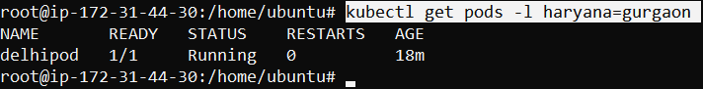

* kubectl get pods -l haryana**!=**gurgaon
* mene yaha **!** laga rakha hai matlab define kar rakha hai ki mujhe vahi pod dikhana jaha par haryana ki value Gurgaon na ho .
* aba mere pass present mein kewal eak hi pod hai isliye vo show nahi kar raha multiple pod hota toh show kar deta.



* **kubectl delete pod -l haryana=Gurgaon**
* agar mujhe apane pod ko label ki help sein delete karna ho toh hum ye command use karenge,
* jaha jaha haryana ki value Gurgaon hogi vo sab pod yein delete kar dega..



* kubectl delete pod -l haryana**!**=Gurgaon
* jis bhi label mein haryana ki value Gurgaon hogi usko chodh kar baki sab pod ko ye command delete kar dega jiski key haryana define huyi hogi
* present mein mere pass koi bhi pod nahi hai isliye



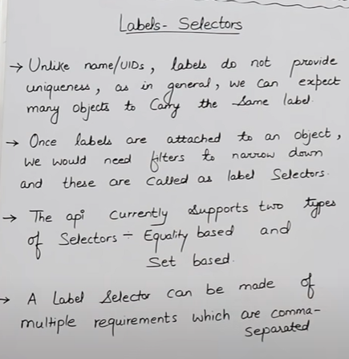 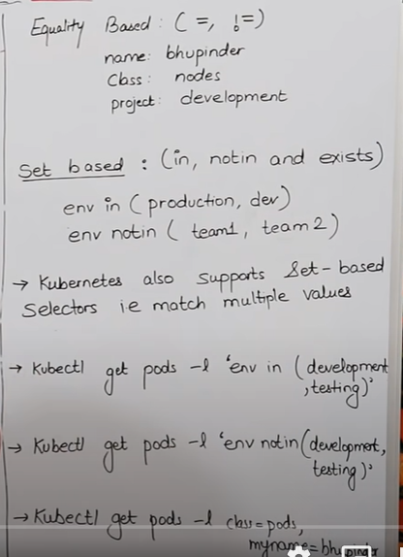

* labels ki koi bhi unique id aur unique name nahi hota,
* hum same tarah ka label multiple pod mein laga sakte hai mlabels ka koi unique id nahi hai ki agar eak pod mein laga diya toh dusare mein nahi laga sakte , humari ichaa hum kitane bhi pod kein andar label laga sakte hai ,
* label ki help sein hum grouping kar sakte hai **for.ex.,** agar mujhecheck karna ho ki Gurgaon haryana kein naam sein jitane bhi pod mein mene label lagaya h sab aajaye toh isase faydaa hai humko ki jitane pod kein andar hum Gurgaon haryana kein naam sein label laga rakhe honge vo sab dikh jayenge yaha.

=========================================================================

**Selector :-**

* hum label kein beech mein jo sign define karte hai usko hum kehate hai selector
* e.x haryana **=** gurgaon , isme = highlight jo kiya hai vo selector hai.
* e.x haryana !**=** gurgaon, isme != selector hai matlab ki not equal to ki haryana ki value jaha Gurgaon na ho vo batao.

**For example:-** create a pod

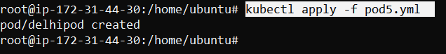

Equality based selector :-

* name=satyam
* profile=software

Not equality based selector:-

* name!=satyam
* profile!=software

Set based selector:- (in, notin, exists)

* kubectl get pods -l 'haryana in (gurgaon,tripathivalue)'

matlab jaha-jaha name ki value satyam aur shivam de rakhi hai vo sab label mujhe dikha do.

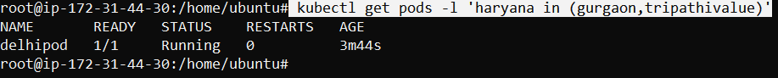

* kubectl get pods -l 'haryana notin (gurgaon,tripathivalue)'

name key kein andar jo bhi satyam aur shivam naam sein value de rakhi hai un sabko chodhkar bakii sab label idhar dikha do .



* kubectl get pods -l haryana=gurgaon,satyamkey=tripathivalue

mene yaha 2 label lagaya hai agar mujhe eak sath multiple label laga kar check karne hai toh hum ye command use karenge.



=========================================================================

**Node Selector**

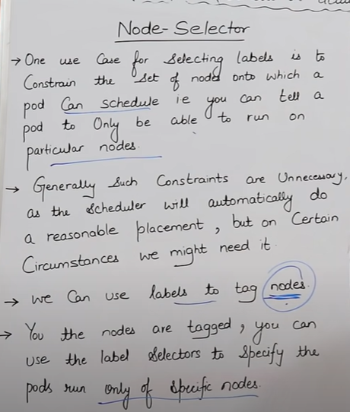 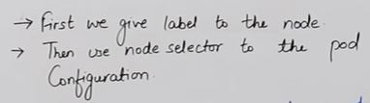

**NODE SELECTOR EXAMPLE**

kind: Pod

apiVersion: v1

metadata:

name: nodelabels

labels:

env: development

spec:

containers:

- name: c00

image: ubuntu

command: ["/bin/bash", "-c", "while true; do echo Hello-Bhupinder; sleep 5 ; done"]

**nodeSelector:**

**hardware: t2-medium**

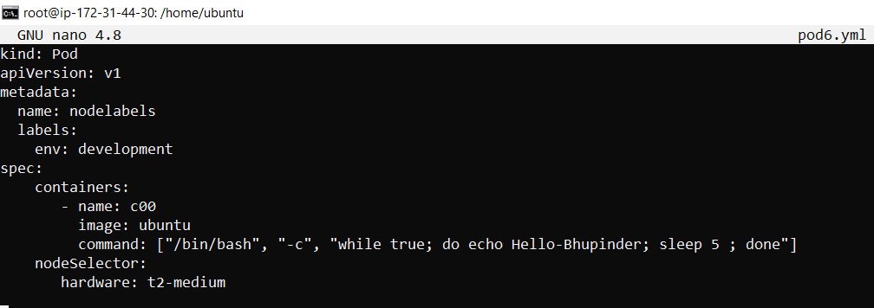

* node selector ka kaam hota hum jis node mein chahe us node mei pod bana sakte hai .
* agar mere pass 4 node bane pade hai A,B,C,D kein naam sein mein chahata hum mera pod mere B node mein jaakar bane toh hum vo bhi kar sakte hai hum b node kein andar jaakr koi label dedenge aur phir vahi label command mein dalunga ki mera pod is label par jaakar ban jaye jaha bhi iss name ka label bana pada hai .
* agar in the case humare pass B naam sein 4 node hai aur mein naya pod banana chahata hu node kein andar toh us case mein kuernetes ko jisme jagah samjh aayegi vo automatically us node mein jaakar pod create kar dega.
* Hum node kein andar label lagayege aur phir vahi label mein pod banante samaye laga dunga ki isi label vale node par jaakar tum pod banao toh vo jaakar vaha bana dega .
* **kubectl get pods**

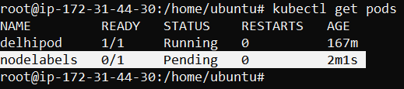

* Isme pending isliye aa raha kyuki mene yml kein andar **node selector** kein andar **hardware** define kiya hai ki , ki jo bhi node kein andar **t2-medium** name sein **label** define huva hai uspar jaakar mera yein pod create kar do but actually mein mere pass koi bhi **t2-medium** label kisi bhi **node par nahi laga hai** iski wajah sein mera pod ban hi nahi paya.
* **kubectl describe pod nodelabels**

hum dekh sakte hai node selectors kein andar **hardware = t2-medium** diya hai label aur present mein humare node kein andar mene

**t2-medium** label nah lagaya hai .

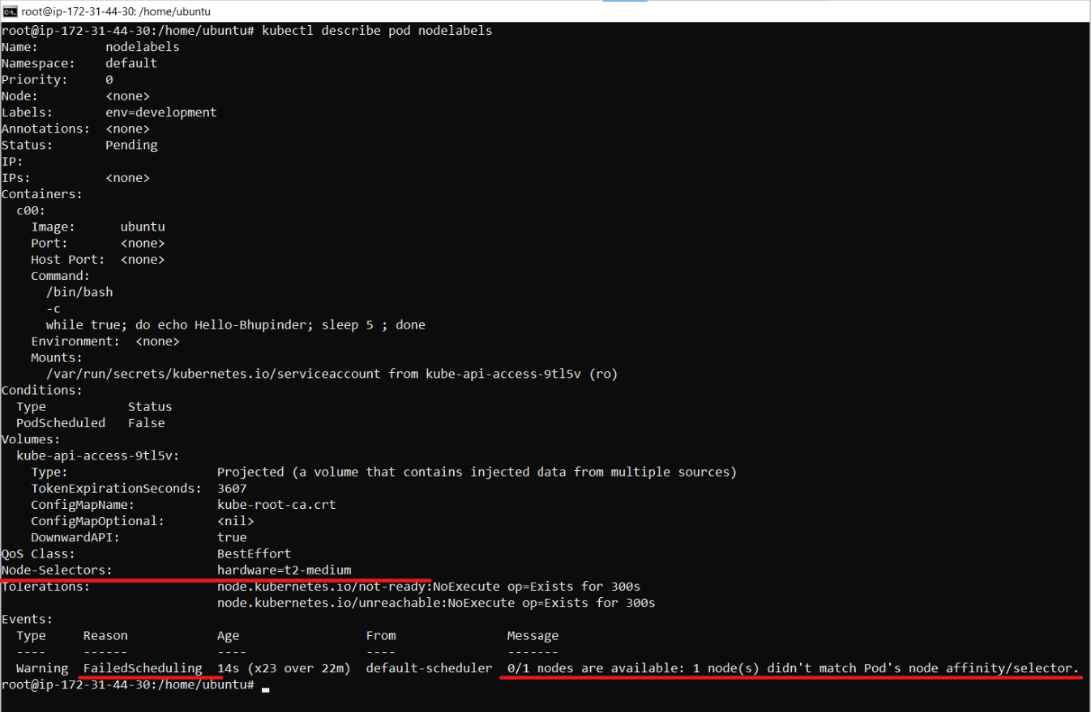

* **kubectl get nodes**

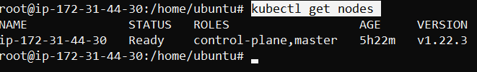

* **kubectl label nodes ip-172-31-44-30 hardware=t2-medium**



Ab mene apane node kein upar label laga diya jisase mera pod connect ho jaye jo mene yml script mein selector lagaya thaa ab mera vo connect ho jayega . kyuki mene yml mein define kar rakha thaa ki jisme hardware= t2-medium label laga ho usi nde mein jaake mera pod banana toh ab iss command sein mene apane node kein andar label laga diya aur ab mera pod connect jayega .

* kubectl get pods

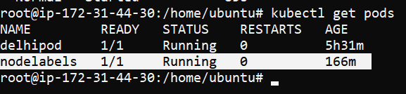

Hum dekh sakte hai ki mera pod ab unning mein aagaya matlab mera pod node sein connect hogaya.

* kubectl delete -f pod6.yml

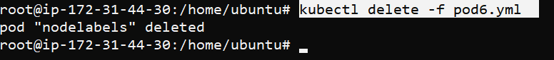

==================================================================

Scalling and replication

Replica :-

* Replica hum kehate hai duplicate pod ko matlab agar humare pass koi pod hai aur hum chahate hai ki is pod ki eak duplicate copy bana kar rakhele toh us duplicate copy of pod ko hum replica kehate hai
* Agar mere pass kisi node kein andar 2 replica hai aur vo dono running zone mein hai aur in the case agar eak pod bhi fail hogaya toh humare user ko dikkat na ho isliye kubernetes mein **replica** naam ki cheej hoti hai, matlab jab humara koi eak pod fail hogaya toh us dauraan bhi humko service deni hogi user ko, jab tak dusara pod recreate nahi hojata isliye agar replica pod hai humare node mein toh vo user ko service dedega.

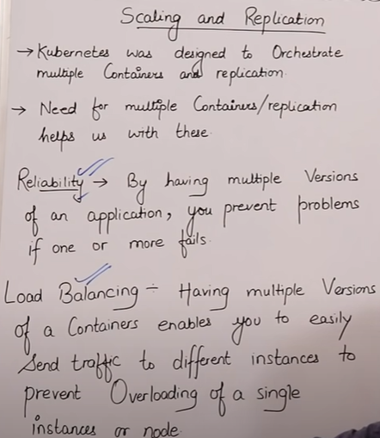

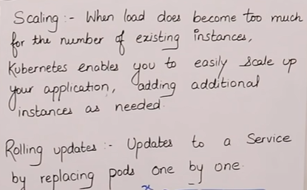

**Load –Balancing =**

* Load balancing kein through hum apane container, pod aur instance sab cheejo ko ghaata badha sakte hai

**Replication Controller**

* Pehle jab hum yml file pod banana kein liye likhate thee toh uske andar **kind : pod** likhate thee toh vo kewal pod create kar deta thaa agar kisi bhi reason sein humara pod cancel ya fail hogaya toh vo dubara apane aapp create nahi ho sakta , but agar hum **kind: replication controller** lagate hai , toh agar pod kisi bhi reason sein failed hota hai toh vo apane aap us pod ko new create kar dega , aur jo pod fail huva thaa uske andar jitane container thee aur data thaa vo sab naye pod kein andar apane aap aajayenge.
* Agar hum yml mein **kind:replication controller** likh rakhe hai toh agar humara pod fail bhi hota hai toh eak naya pod apane aap create kardega apane aap .
* Replication controller hardum recommend karta hai ki humara minimum **eak pod** hardum running condition mein ho, matlab replica= 1 likhenge toh 1 replica matlab eak pod create hoga replica= 2 likhenge toh 2 pod create hoga , jitana likheneg utani replica create hogi .

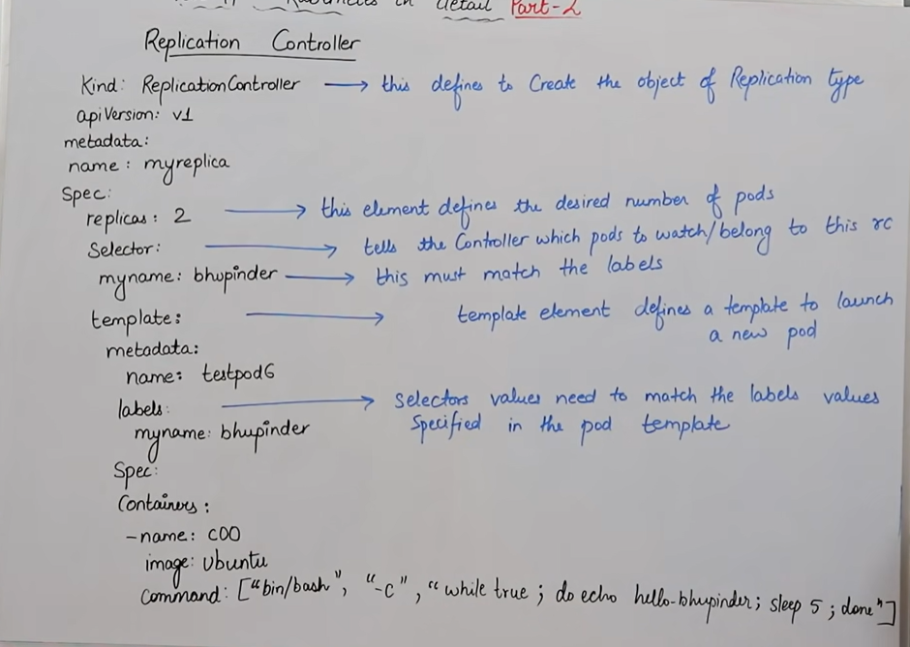

**REPLICATION CONTROLLER YML**

**kind: ReplicationController**

**apiVersion: v1**

**metadata:**

**name: myreplica**

**spec:**

**replicas: 2**

**selector:**

**myname: Satyam**

**template:**

**metadata:**

**name: testpod6**

**labels:**

**myname: Satyam**

**spec:**

**containers:**

**- name: c00**

**image: ubuntu**

**command: ["/bin/bash", "-c", "while true; do echo Hello-India; sleep 5 ; done"]**

**Kind: replication controller**

* **nano pod.yml**

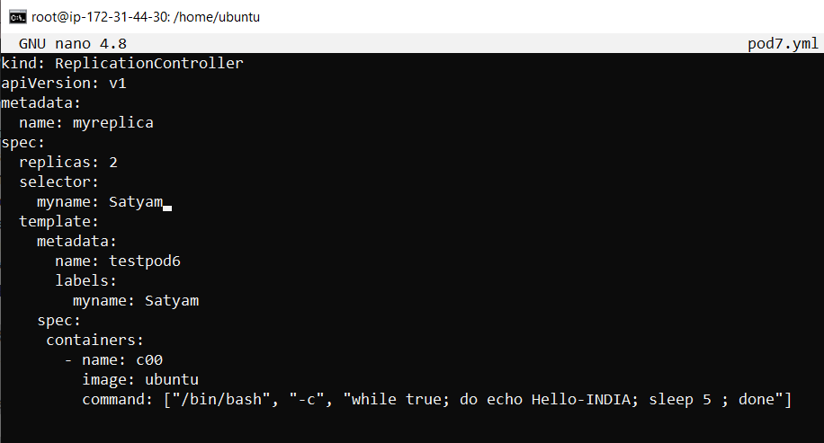

* replicas: 2
* Iska matlab mene 5 pod create kiya hai
* selector:

myname: Satyam

iska matlab mene replica kein andar selector lagaya hai ki agar satyam naam sein related koi pod fail hota hai toh usko phir sein create kardo .

aur mene myname:satyam eak label laga rakha hai .

**template:**

**metadata:**

**name: testpod6**

**labels:**

**myname: Tripathi**

* mene eak template bana rakha hai matlab ki jab mera pod fail ho toh is template kein hi basis par mera naya pod create kar do ,jaise mene 5 replica likha hai matlab mere 5 pod create kar do same template kein.

**labels:**

**myname: Satyam**

* mene jo name selector kein andar de rakha hai vahi name same mujhe apane label kein andar bhi dena hoga nahi toh error aayega ,aisa isliye kyu ki same label name millega tabhi aake vo naya pod create kar payega nahi toh nahi kar pyega.
* kubectl apply -f pod7.yml
* kubectl get rc 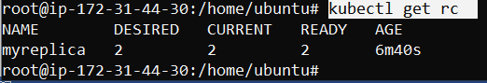

mein dekh sakta hu mene apane yml file mein likha thaa ki mujhe 2 replica chahiye toh isane 2 replica create kar di.

**rc** matlab replication controller ,matlab mein apana replica check karna chah raha

mene 2 desired state dalli thii aur vo dono sahi chal rahi hum dekh sakte ha image mein.

* kubectl describe rc myreplica

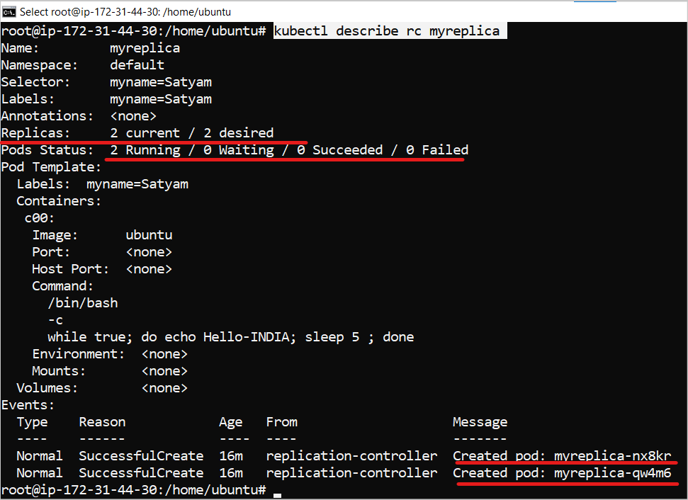

Mene apane yml file kein andar jo naam diye hoga usko hi daal kar search karenge, toh aajayega , hum dekh sakte ha meri desired state aur running state same hai .

* **kubectl get pods**

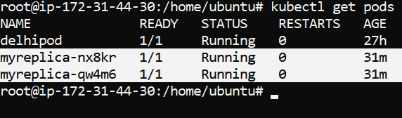

* **kubectl delete pod myreplica-nx8kr**

agar mein apana eak pod delete kar raha toh mein ye command use karunga, but pod delete jaise hoga turant eak naya pod apane aap create kar dega ,

yahi replica ka fayada hota hai ki agar pod fail hogaya toh apane aap create kar dega naya pod

aur ab jo naya pod create huva hai uska name or ip dono change hai.

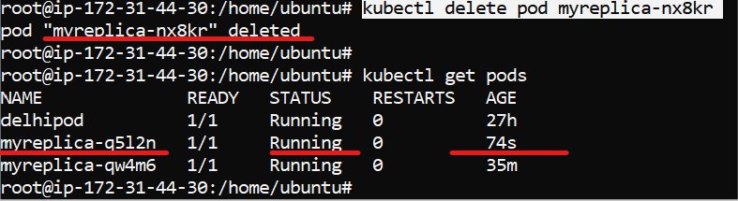

* **kubectl get rc**

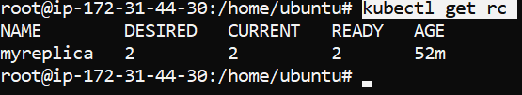

* **kubectl describe rc myreplica**

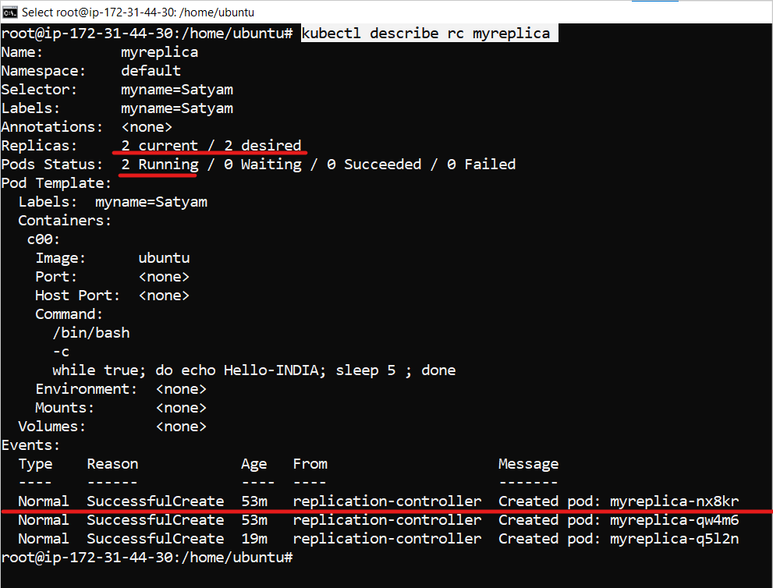

Mein red line event mein jo underline kiya hai ye mene delete kar diya thaa pod isliye event mein ye bhi shw ho raha hm jo bhi create karenge bhalle vo delete ho jaye but isme dikhega vo event kein andar

Hum dekh sakte hai humar desired 2 replics hai jo ki fullfill hai , mene pod delete karne kein baad khud pod nahi banaya yml file mein replica define hai isliye kubernetes apane aap naya pod create kar diya .

scalling

* **kubectl scale --replicas=8 rc -l myname=Satyam**



Ye command hum tab use karte hai jab humko replica badhani ho ya kaam karana ho .

Mene isliye scale likha hai phir replica=8 isliye likha ki 8 replica banana hai , phir mene label lagaya hai myname=satyam ,matlab ye label jaha mlle vaha jaakar 8 replica create kar do .

Hum output mein dekh sakte hai humari replica scalled hogayi hai .

Iss process ko hum scale-up replica kehate hai

* kubectl get rc

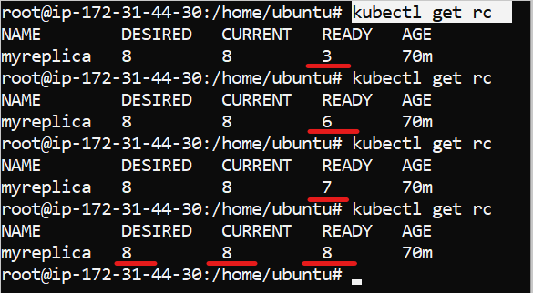

Hum dekh sakte hai humari replica dheere-dheere create ho rahi, mene 5 second mein yein 3 baar chalaya aur phir 3 second mein isane sab po ready kar diye .

* **kubectl get pods**

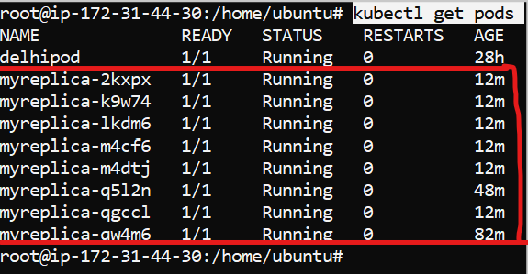

Ab humare pass 8 pod ban gaye hai .

* kubectl scale --replicas**=1** rc -l myname=Satyam



Hum dekh sakte hai ki humare pass kewal 1 replica bachiii.baki sab delete ho gayi , is process ko hum scale down kehate hai

* **kubectl get rc**

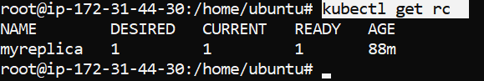

Now , we have only one replica .

* kubectl get pods

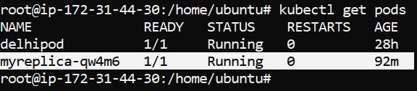

* kubectl delete -f pod7.yml



* kubectl get rc

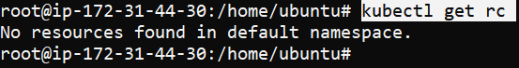

* kubectl get pods

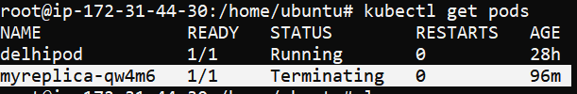

Now replica terminating is process

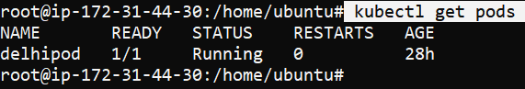

Terminated

**Replica Set**

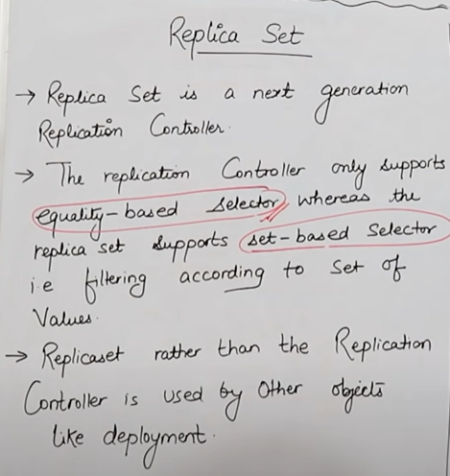

**Difference between Replication controller & Replica based set**

**Replication control =** Equality based selector hota hai

**Replica based set =** Set based selector hota hai ye

Replica based set **Replication control** ka **advanced version** hai .

Ye **replication control** aur **replica based** dono par kaam karta hai .

Dono mein difference ye hai ki hum yml file kein andar jo version likhate the replication control mein usme hum v1 kein pehale app nahi likhate thee e.x ,

but replica based mein hum **api/version = apps/v1**

* Pehale replication control used hota thaa but ab replica set use hota aisa isliye kyu ki **replication control** mein kewal **equality or not equality selector** hum use kar sakte thee, but hum **replica set** kein andar **multiple selector** use kar sakte hai

**EXAMPLE OF REPLICA SET**

**kind: ReplicaSet**

**apiVersion: apps/v1**

**metadata:**

**name: myrs**

**spec:**

**replicas: 2**

**selector:**

**matchExpressions: # these must match the labels**

**- {key: myname, operator: In, values: [satyam, shivam, sundaram]}**

**- {key: env, operator: NotIn, values: [production]}**

**template:**

**metadata:**

**name: testpod7**

**labels:**

**myname: shivam**

**spec:**

**containers:**

**- name: c00**

**image: ubuntu**

**command: ["/bin/bash", "-c", "while true; do echo Hello India; sleep 5 ; done"]**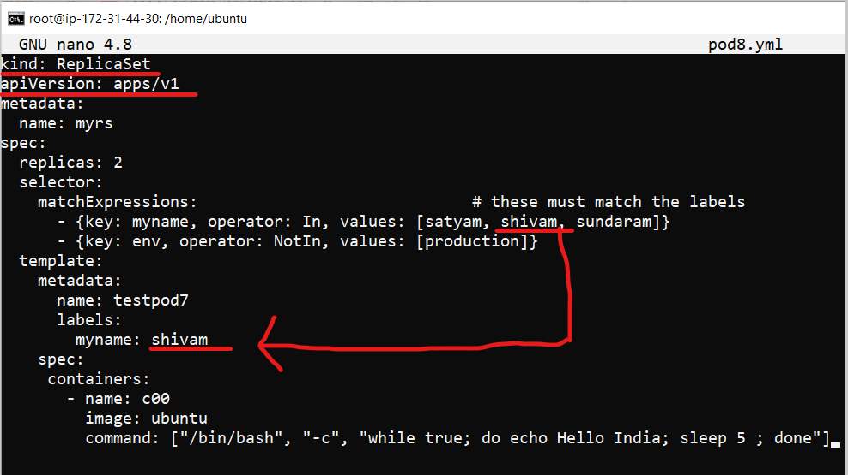

mene label mein shivam naam define kiya hai , aur selector kein andar mene shivam name define kar rakha hai matlab agar usko shivam naam ka label kahi millega toh vo jaakar ;od create kar dega

* kubectl apply -f pod8.yml



* kubectl get rs

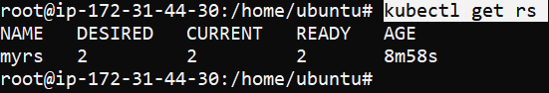

* kubectl get pods

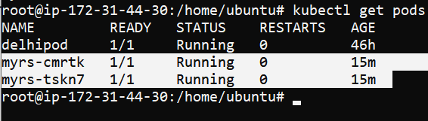

* **kubectl scale --replicas=1 rs/myrs**



mene **myrs** apane pod ka name yml mein diya hai aur mene yml file mein pehale usko 2 pod diye theebut ab kam kar diya ab 2 sein ghata kar mene eak replica kar diya

hum replica ko badha aur ghata dono sakte hai .

* **kubectl get pods**

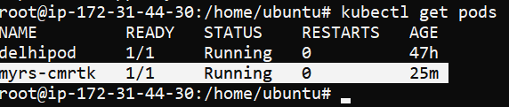

Hum dekh sakte hai ab humare pass kewal 1 pod bacha huva hai .

* **Kubectl get rs**

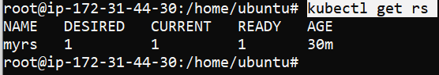

Ab mere pass kewal eak replica bachi huyi hai

* **kubectl delete pod myrs-cmrtk**

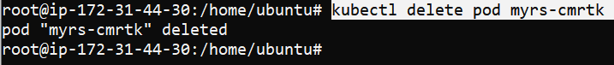

Mere pass **myrs-cmrtk** iss naam ka jo bana thaa mene usko delete kar diya **.**

* **kubectl get pods**

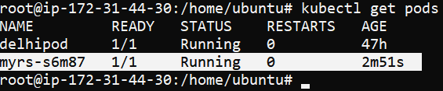

Mein dekh sakta hu ki mere pass **myrs-s6m87** nam ka naya pod create hogaya aisa isliye kyuki mene **replica** eak bana rakhi hai jaise hi pod delete huva vo automatically same replica create kardegi means , do option ho sakta hai pod delete karne kay ya toh replica 0 kar de ya toh phir yml file hi delete kar de. Aur hum replica delete kar denge tabh sab pod hat jayenge .

* **Kubectl delete rs/myrs**

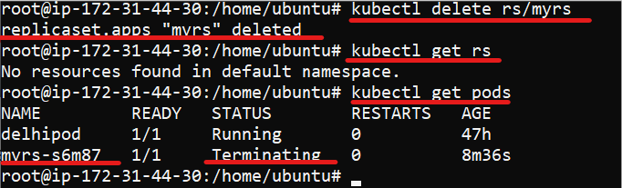

Mein yaha replica-set hi delete kar diya toh iss wajah sein ab mere pass ab yaha koi replica bachi h nahi aur jab mene pod check kiya toh mere pass koi pod bhi nahi bacha.

* Kubectl get pods

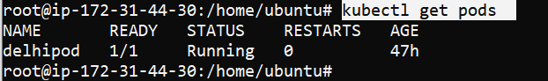

Mein dekh sakta hu mere pass ab yaha koi bhi pod nahi bache huye sab delete hog aye hai